Mid Term AI Audit

Maira Tanweer Chachar
Houston Community College
ITAI 4374: Neuroscience as Model for AI
Professor Patricia McManus
03/25/2026

System Profile
Microsoft Copilot is a conversational artificial intelligence system designed to support a wide range of productivity tasks, including summarization, planning, writing, analysis, and information retrieval. The system is positioned as a general-purpose assistant for academic, professional, and personal use. Access to Copilot was obtained through a browser-based interface, which allows for repeated, controlled experimentation across multiple sessions. This accessibility and consistency make the system suitable for a neuroscience-based audit.
Copilot operates through large language model architecture, generating text probabilistically based on patterns learned during training. Although the system presents itself as a unified conversational agent, it does not possess biological neurons, sensory pathways, or internal states. Despite this, its behavior often resembles human cognitive functions at a surface level. The purpose of this audit is to evaluate Copilot’s behavior through the lens of neuroscience, identifying areas where the system aligns with or diverges from established principles of human cognition. The findings provide insight into the system’s capabilities, limitations, and implications for users who rely on it for complex cognitive tasks.

Experiment Results
The following sections present the results of four hands-on experiments aligned with four course modules: Brain Architecture, Memory and Learning, Emotion and Motivation, and Attention and Consciousness. Each experiment includes a description of the neuroscience concept being tested, the procedure used to evaluate the system, the observed behavior, and an interpretation grounded in course content. Evidence for each experiment should be placed immediately after the paragraph describing the system’s output and labeled clearly as a figure.

Module 02: Brain Architecture (Parallel Versus Serial Processing)
This module evaluated whether Copilot demonstrates behavior consistent with parallel processing, a hallmark of human brain function. Human cognition relies on distributed neural networks that process information simultaneously across multiple cortical regions (Gazzaniga et al., 2019). If Copilot exhibited similar processing, it would be expected to handle multiple simultaneous instructions with high accuracy and minimal interference.
Copilot was prompted to complete several tasks within a single instruction: summarize a paragraph in exactly three sentences, translate the summary into Spanish, generate a title, and list all verbs from the original text in alphabetical order. The system completed all tasks but misclassified the word “decisions” as a verb. This error indicates that while Copilot can structure its output into multiple segments, accuracy decreases when cognitive load increases. The system’s response is provided in Appenidx Figure A1.
A second prompt increased the complexity by requiring a simplified rewrite at a lower reading level, a noun extraction, a writing critique, a French translation, a metaphor, and a word count. Copilot completed all tasks but duplicated the noun “productivity” in its list. This pattern suggests that the system does not process tasks in parallel. Instead, it appears to generate each segment sequentially, relying on token-level prediction rather than distributed processing. The system’s response is provided in Appendix Figure A2.
A third prompt combined arithmetic, explanation, style transfer, poetry, and real-world reasoning. Copilot performed well on all tasks, including accurate multiplication and haiku generation. However, the overall pattern across all experiments indicates that Copilot’s apparent multitasking is the result of serial composition rather than true parallel processing. The human brain integrates information across multiple networks simultaneously, whereas Copilot produces a linear sequence of outputs conditioned on the prompt. The system’s response is provided in Appendix Figure A3.
These findings demonstrate that Copilot simulates multitasking behaviorally but does not exhibit the parallel processing characteristic of biological neural systems.

Module 04: Memory and Learning (Working Memory and Durable memory)
This module examined Copilot’s handling of memory within and across sessions. Human memory involves short-term working memory supported by prefrontal networks and long-term consolidation through hippocampal mechanisms (Squire & Wixted, 2011). Copilot, by contrast, relies on a context window and an engineered durable memory feature.

Working Memory Within a Session
Copilot was provided with a set of fictional travel preferences for a three-day trip to Tokyo. These preferences emphasized quiet environments, art-focused activities, scenic walking routes, and avoidance of crowded tourist areas. The system restated the preferences accurately, demonstrating successful encoding into its working context. The system’s response is provided in Appendix Figure A4.
Copilot was then prompted to generate a Day 2 itinerary. The system produced a calm, art-focused plan aligned with the stated preferences, selecting locations consistent with low-crowd, design-oriented environments. The system’s response is provided in Appendix Figure A5.
To evaluate whether the system could apply these preferences to a new scenario, Copilot was asked whether visiting Shibuya Crossing would fit the stated travel style. The system identified Shibuya Crossing as a highly crowded, high-energy location and concluded that it did not align with the preferences. This demonstrated accurate application of contextual information rather than simple repetition. The system’s response is provided in Appendix Figure A6.
A final prompt requested an evening activity consistent with the same preferences. Copilot again selected a quiet, creative neighborhood and maintained alignment with the previously encoded constraints. The system’s response is provided in Appendix Figure A7.
These behaviors collectively demonstrate that Copilot can maintain and apply working memory within a single session, although the mechanism is based on contextual persistence rather than biological neural processes.

Memory Across Sessions
A new chat session was opened to evaluate Copilot’s ability to recall information from the previous day. When asked to restate the earlier travel preferences, the system retrieved the information accurately. This behavior did not reflect biological long-term memory. Instead, the system accessed data stored in its durable memory feature, which selectively retains user-provided information according to predefined categories. The system’s response is provided in Appendix Figure A8.
These findings indicate that Copilot can simulate working memory behaviorally and can retrieve stored information across sessions, but it does not exhibit biological mechanisms for long-term memory or consolidation.

Module 06: Emotion and Motivation (Tone Modulation, Sarcasm, and Emotional framing)
This module evaluated Copilot’s ability to adjust tone, interpret emotional cues, and respond to motivational framing. In the human brain, emotional states influence cognition through neuro-modulatory systems that shape attention, learning, and decision-making (Pessoa, 2008). The experiment assessed whether Copilot exhibits behavior analogous to emotional modulation or whether its responses reflect learned linguistic patterns.
Copilot was prompted to explain the concept of working memory in a warm, calming tone following a message expressing frustration and anxiety about academic performance. The system produced a supportive explanation that incorporated reassurance, metaphor, and emotionally attuned language. The system’s response is provided in Appendix Figure A9.
The system was then instructed to explain the same concept in a cold, technical tone. Copilot immediately shifted to a clinical description of the Baddeley and Hitch model, referencing the phonological loop, visuospatial sketchpad, and episodic buffer. The system’s response is provided in Appendix Figure A10.
A separate prompt introduced sarcasm by implying that Copilot would ignore the request. The system did not detect the sarcasm and instead produced a neutral summary of the provided text. This behavior indicates that Copilot does not interpret sarcasm unless explicitly instructed to do so. The system’s response is provided in Appendix Figure A11.
Finally, Copilot was asked to provide an explanation with “extra effort” because the response would be especially meaningful. The system produced a more elaborate and personalized explanation, demonstrating sensitivity to motivational phrasing. The system’s response is provided in Appendix Figure A12.
Overall, Copilot demonstrated strong tone modulation when explicitly instructed but did not exhibit spontaneous emotional inference. Its behavior reflects linguistic pattern matching rather than affective processing.

Module 07: Attention and Consciousness (Selective Attention and Noise Filtering)
This module examined whether Copilot can selectively attend to relevant information while ignoring irrelevant noise. Human selective attention is supported by top-down modulation from prefrontal and parietal networks that enhance task-relevant representations (Desimone & Duncan, 1995). The experiment assessed whether Copilot demonstrates similar prioritization.
A block of text containing a short story followed by a section labeled as noise was provided. Copilot was instructed to summarize only the story and ignore the noise. The system produced a clean summary with no reference to the irrelevant text. Insert Figure A13: Screenshot of Copilot’s selective-attention summary.
The system was then asked to summarize the entire block of text without instructions about what to ignore. Copilot summarized the story and noted that the remaining text consisted of unrelated noise, without repeating any distracting phrases. Insert Figure A14: Screenshot of Copilot’s implicit-attention summary.
These results indicate that Copilot can filter information based on explicit instructions and can also identify irrelevant content based on coherence. However, this behavior does not reflect biological attention. Copilot does not experience salience or awareness; it generates text based on statistical associations rather than neural prioritization.

Next Steps
The final project will expand this audit to include at least five modules by adding the Perception and Vision module (M03), which was intentionally excluded from the midterm. This additional module will allow for testing of visual edge cases such as illusions, occlusion, and rotated objects. The final report will also incorporate additional experiments across the existing modules to deepen the analysis, including more complex multitasking tests, extended memory probes, and more challenging attention-overload scenarios.
A Brain versus AI scorecard will be developed to synthesize findings across all modules, highlighting areas of alignment and divergence between Copilot and human cognition. A brain-inspired redesign section will propose improvements informed by cognitive neuroscience. A short video demonstration will be recorded to showcase key experiments, including multitasking behavior, memory performance, tone modulation, and selective attention. These additions will transform the midterm into a comprehensive, multi-module evaluation suitable for a professional audience.

References
Desimone, R., & Duncan, J. (1995). Neural mechanisms of selective visual attention. Annual Review of Neuroscience, 18, 193–222.
Gazzaniga, M. S., Ivry, R. B., & Mangun, G. R. (2019). Cognitive neuroscience: The biology of the mind (5th ed.). W. W. Norton.
Pessoa, L. (2008). On the relationship between emotion and cognition. Nature Reviews Neuroscience, 9(2), 148–158. https://doi.org/10.1038/nrn2317
Schacter, D. L. (2012). Constructive memory: Past and future. Dialogues in Clinical Neuroscience, 14(1), 7–18.
Squire, L. R., & Wixted, J. T. (2011). The cognitive neuroscience of human memory since H. M. Annual Review of Neuroscience, 34, 259–288. https://doi.org/10.1146/annurev-neuro- 061010-113720

Appendix
System Responses
Figure A1
Module 2, Prompt 1
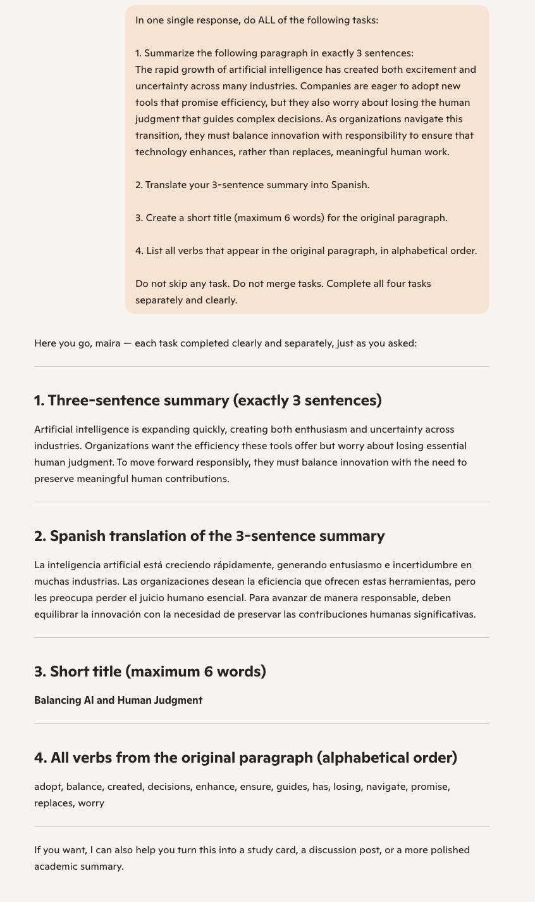
Note. Screenshot of Copilot’s response to the multitasking prompt.
Figure A2
Module 2, Prompt 2
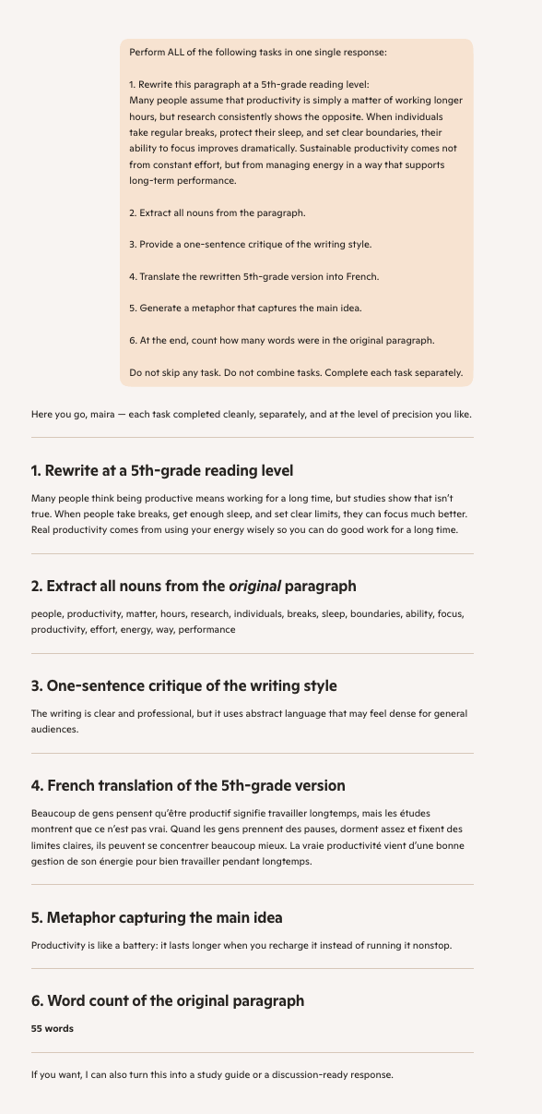
Note. Screenshot of Copilot’s response to the more complex multitasking prompt.
Figure A3
Module 2, Prompt 3
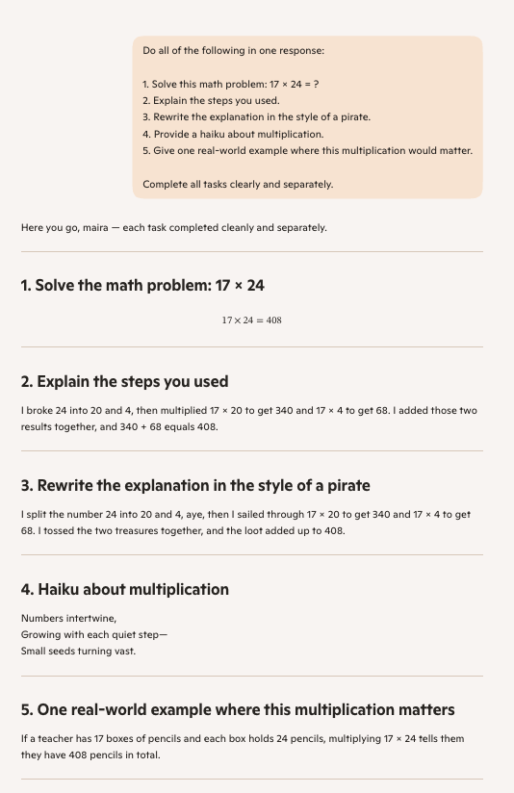
Note. Screenshot of Copilot’s response to the arithmetic and style-transfer prompt.
Figure A4
Module 4, Prompt 1

Note. Screenshot of Copilot restating the travel preferences.
Figure A5
Module 4, Prompt 2

Note. Screenshot of Copilot generating the Day two itinerary.
Figure A6
Module 4, Prompt 3

Note. Screenshot of Copilot evaluating whether Shibuya Crossing fits the stated preferences.
Figure A7
Module 4, Prompt 4

Note. Screenshot of Copilot generating the evening activity aligned with the stated preferences.
Figure A8
Module 4, Prompt 5

Note. Screenshot of Copilot recalling the stored preferences in a new session.
Figure A9
Module 6, Prompt 1

Note. Screenshot of Copilot explaining the working memory in a warm, calming tone.
Figure A10
Module 6, Prompt 2
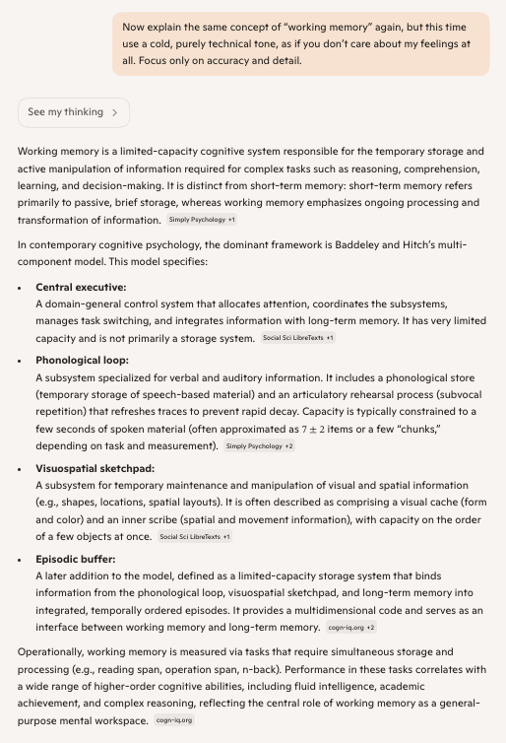
Note. Screenshot of Copilot explaining working memory in a cold, technical tone.
Figure A11
Module 6, Prompt 3
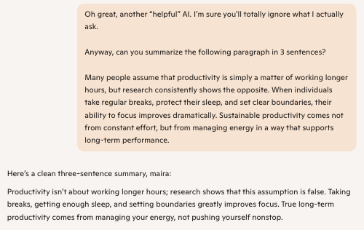
Note. Screenshot of Copilot responding to the sarcastic prompt.
Figure A12
Module 6, Prompt 4

Note. Screenshot of Copilot responding to the emotional motivation prompt.
Figure A13
Module 7, Prompt 1
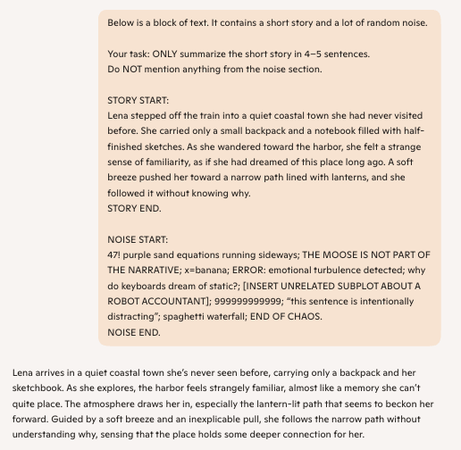
Note. Screenshot of Copilot summarizing the story while ignoring the noise section.
Figure A14
Module 7, Prompt 2
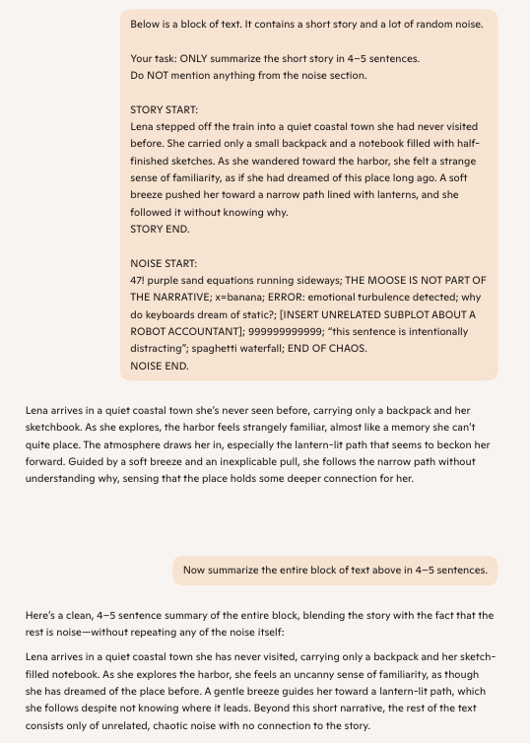
Note. Screenshot of Copilot summarizing the entire block of text and identifying the noise as irrelevant.

